CANT FIND ENV ISSUE FIX!
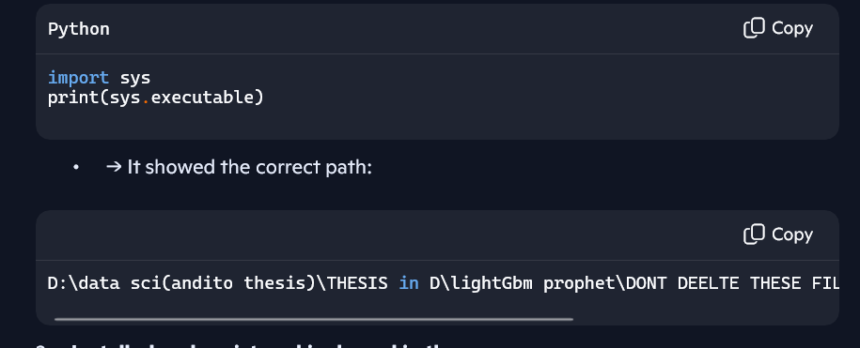IF FAILED DO THIS
MAKE SURE ENV IS ACTIVATED (In PS D:\data sci(andito thesis)\THESIS in D\lightGbm prophet\DONT DEELTE THESE FILES> .\prophetneural\Scripts\activate
(prophetneural) PS D:\data sci(andito thesis)\THESIS in D\lightGbm prophet\DONT DEELTE THESE FILES>

pip install ipykernel
python -m ipykernel install --user --name=prophetneural --display-name "Python (prophetneural D)"

check
C:\Users\Jaspher\AppData\Roaming\jupyter\kernels\prophetneural\
IF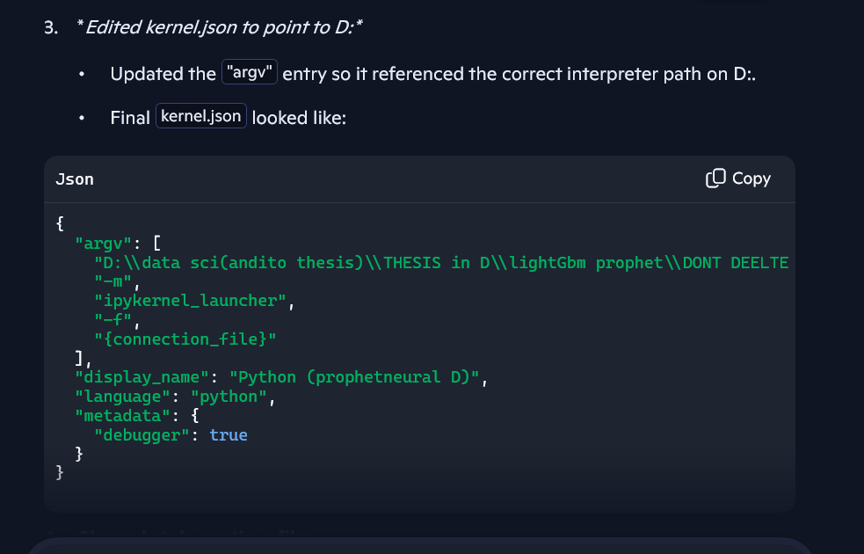
{
"argv": [
"D:\\data sci(andito thesis)\\THESIS in D\\lightGbm prophet\\DONT DEELTE THESE FILES\\prophetneural\\Scripts\\python.exe",
"-m",
"ipykernel_launcher",
"-f",
"{connection_file}"
],
"display_name": "Python (prophetneural D)",
"language": "python",
"metadata": {
"debugger": true
}
}
THEN GOOD!
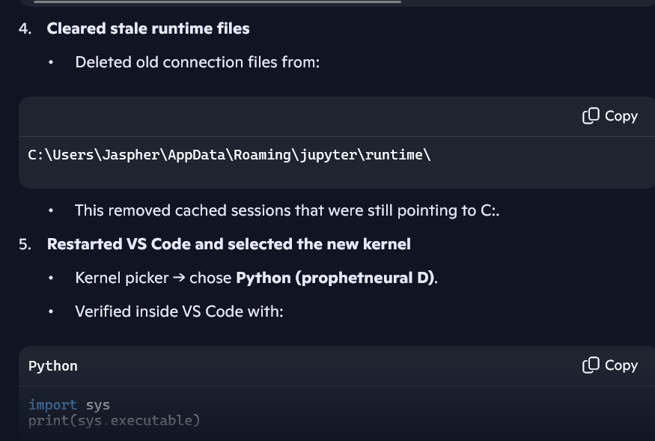
If failed RE-PROMPT!

